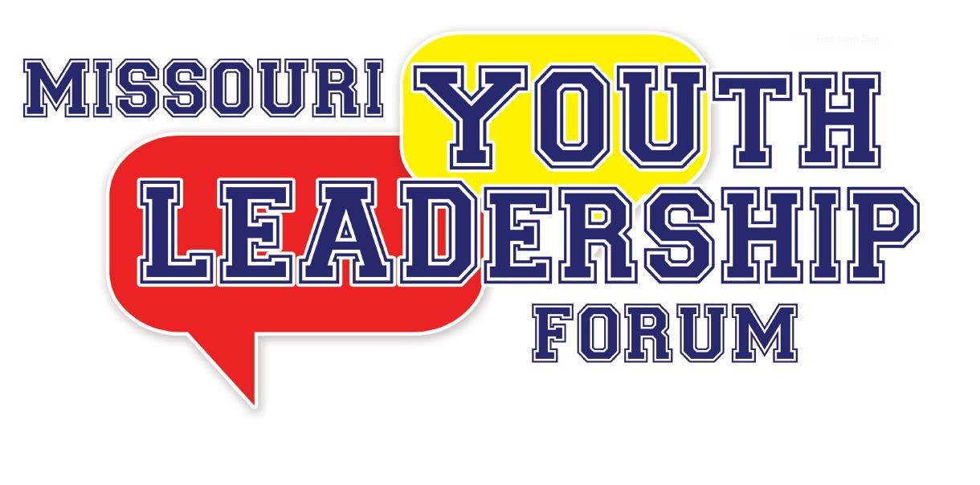
Volunteer Staff Application Form

Please read all instructions. Please fill out the entire application marking sections that do not apply appropriately with N/A. The application deadline is May 15, 2022. There is a fixed number of volunteer staff positions. Return completed applications to:

Options for submitting your completed application:

Upload to:
Youth Leadership Forum (mo.gov)

Fax to:
573-526-4109

Mailing to:
Governor’s Council on Disability
Missouri Youth Leadership Forum
PO Box 1668
Jefferson City, MO 65102

Have questions or need assistance submitting your application?
Call: 800-877-8249 or 573-751-2600
OR
Email: rachel.rackers@oa.mo.gov

2022 MISSOURI YOUTH LEADERSHIP FORM
VOLUNTEER STAFF APPLICATION

Staff Dates: Monday, July 11, 2022 through Saturday, July 16, 2022
Application deadline is May 15, 2022

Name: Date:

Mailing Address:
City: State: Zip Code:

Telephone: E-mail:
T-Shirt Size: Position Interested In:
======================================================================================================

Applicant Status: Check ALL that apply:

New Staff Applicant

YLF Alumni, if checked, year you attended YLF

Former YLF staff member, year(s) on staff

If you are a staff member who has a disability or medical condition describe any accessibility or accommodation needs required during the week. Since most equipment will be rented for the week, failure to state equipment required for accommodations (ie wheelchair, shower chair, etc) may lead to those accommodations not being available during YLF.
[Use the back of this page if necessary. Response required even if it is non-applicable (N/A).]

Medical Information

Medical Plan:
Name Address City

Policy Holder: Policy Number:

Family Physician:
Name (Area Code) Telephone

Person to notify in case of an emergency (please provide two names):
Name: Relationship:

Address:
City State Zip Code

Telephone Number: Cell Phone:
(Area Code) (Area Code)

Name: Relationship:

Address:
City State Zip Code

Telephone Number: Cell Phone:
(Area Code) (Area Code)

Are you currently under a doctor’s care? If yes, please explain:

Please list any allergies that you have(food, medication, animals, etc.):

Do you have any special dietary needs? Yes No If yes, please specify:

Please share any additional medical information that you feel would be beneficial to a doctor in case of an emergency.

======================================================================================================
Background Check Information

Full Legal Name:

Social Security Number:

Birthday:

The above information will only be used to do a criminal background check through the Family Care Registry, which is required for volunteers who work with minors. By signing below you give the YLF Planning Committe permission to conduct the background checks as necessary for your participation in the 2020 YLF.

Signature:

======================================================================================================

REFERENCES (please list three, include telephone number)

- Name: Telephone:

- Name: Telephone:

- Name: Telephone:

If selected as a Facilitator or Team Member, I will make my self available for the Youth Leadership Forum beginning at 1:00 p.m., Monday, July 11, 2022 through 3:00 p.m., Saturday,
July 16, 2022. I understand that once the delegates arrive on July 12, 2022, I must stay with the delegates at all times (ie, can not leave dorm at night or campus during the day) until checkout on July 18, 2020. I also agree to follow all University of Missouri Columbia resident hall rules and regulations pertaining to my participation in YLF. If I am unable to fulfill this position, I will let Rachel know ASAP in order to fill my spot with someone else. For any clarification or questions, I will contact Rachel at (573) 526-4564 or rachel.rackers@oa.mo.gov

Signature:

A mandatory paragraph must be written describing your motivation to be a staff member for the Youth Leadership Forum. If you are an alumni, you must write a paragraph on how you have utilized leadership skills gained at previous YLF programs in your community. Applications submitted without completing the following paragraph will not be considered.

