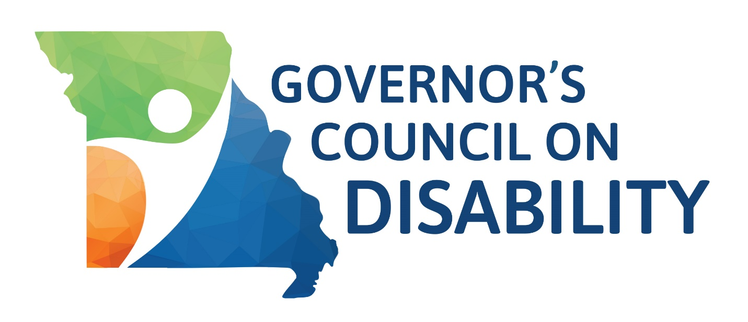

Governor's Council on Disability 2024 Legislative Priorities Poll

The Poll has various sections: Demographics, topic areas, Legislative Update sign up, and contact information. The open answer questions are optional for all individuals. We will share the results with all state legislators early in the 2025 legislative session to inform them of issues important to the disability community.  
  
***Deadline: November 1, 2024***

**Demographics**

Please indicate what county you live in:

Please indicate your zip code:

Please indicate which describes where you live:

Urban

Suburban

Rural

Please indicate whether you are a: (select all that apply)

Person with a disability

Family member

Friend

Government agency

Service provider

Educator

Employer

Personal Care Attendant/aide/Direct Support Professional

Other

If you have a disability, please indicate which type(s) (Optional)

Blind/Low vision

Cognitive

Chronic health condition

Deaf/Hard of Hearing

Developmental

Intellectual

Learning

Mobility

Multiple chemical sensitivity

Other

Psychological

**Accessibility**

The State of Missouri should ensure person first language is used on all state associated websites.

Strongly Agree

Agree

Neutral

Disagree

Strongly Disagree

The State of Missouri should update websites to include more language that is direct and easy to understand for those with reading or writing difficulties.

Strongly Agree

Agree

Neutral

Disagree

Strongly Disagree

Have you or others had difficulty accessing services from a state department.

Yes

No

Which department(s) have you had difficulty accessing services from? (Only answer if Yes is marked for the previous question)

Department of Elementary and Secondary Education

Department of Health and Senior Services

Department of Mental Health

Department of Revenue

Department of Social Services

Other (Please indicate which Department)

What is the most important issue with accessibility in Missouri for people with disabilities and what changes could state legislators make to improve it?

**Education**

**If you are a parent of a school-age child with a disability**, have you experienced any difficulties in making sure your child has an appropriate education?

Yes

No

What challenges do you experience making sure your child receives an appropriate education? (Only answer if Yes is marked for the previous question)

What is the most important issue with education in Missouri for people with disabilities and what changes could state legislators make to improve it?

**Assistance Services and Health Care**

The personal care attendant/aide/ direct support professional workforce provides critical services to people with disabilities.

Strongly Agree

Agree

Neutral

Disagree

Strongly Disagree

Do you use Personal Care Attendant/aide/ Direct Support Professional services?

Yes

No

Please indicate which, if any, health care services you have difficulty with.

Finding/hiring/retaining a Personal Care Attendant/aide/Direct Support Professional

Appropriate number of personal care hours to meet needs

Dental care

Mental health services

Appropriate accommodations to meet health care needs

Transportation to/from health care appointments

Providers who accept your insurance

Ancillary services (Examples: imaging, rehabilitation, massage/chiropractic)

None of the above

What is the most important issue with personal assistance services or health care in Missouri for people with disabilities and what changes could state legislators make to improve it?

**Housing**

Do you or someone you know with a disability no longer have a home because of increasing property taxes?

Yes

No

There should be a freeze (stay the same) on property taxes for people with disabilities.

Strongly Agree

Agree

Neutral

Disagree

Strongly Disagree

The Senior Citizen Property Tax Credit (circuit breaker) needs to be updated.

Strongly Agree

Agree

Neutral

Disagree

Strongly Disagree

Is accessible housing available in your community?

Yes

No

Do you have difficulty finding available rental properties that are affordable and meet your needs?

Yes

No

Not Applicable

Have you or someone you know experienced discrimination in renting because of a disability?

Yes

No

Have you or someone you know experienced rental application rejections because of a disability?

Yes

No

What is the most important issue with housing in Missouri for people with disabilities and what changes could state legislators make to improve it?

**Employment**

**If you have a disability**, do you currently have a job or are looking for a job?

Yes, currently have a job

Yes, looking for a job

No

What motivates you to get a job? (Only answer if Yes, looking for a job is marked for the previous question)

Income

Skill development

Full-time hours

Socialization

Benefits

Not Applicable

Describe any barriers people with disabilities may experience when attempting to obtain employment.

What is the most important issue with employment in Missouri for people with disabilities and what changes could state legislators make to improve it?

**Transportation**

What types of transportation do people with disabilities use in your community?

Drive a vehicle

Use an Uber, Lyft, taxi

Rely on family/friends/aide

Walk/bike

Use public transportation

What barriers does a lack of transportation provide for people with disabilities?

What is the most important issue with transportation in Missouri for people with disabilities and what changes could state legislators make to improve it?

**Legislative Update and Contact Information**

The Governor's Council on Disability sends out a Legislative Update each week of the legislative session which tracks disability-related bills. If you do NOT receive the GCD Legislative Update and would like to be added to the listserv, please provide your name and email address here.

**If you already receive it, please do NOT provide it again**.

Please provide your contact information (Optional)

Name

Address

Address 2

City

State

Zip Code

Email Address

Company