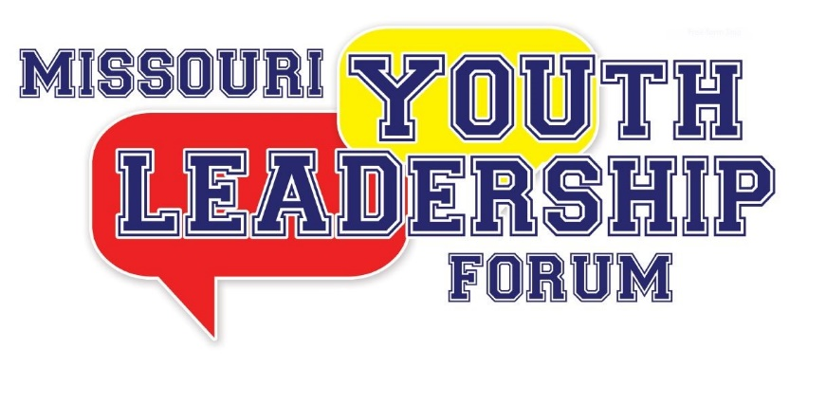
Volunteer Staff Application Form
For *Virtual* Regional Leadership Forum

Return completed applications to:

Missouri Youth Leadership Forum
301 West High Street, Room 840
PO Box 1668
Jefferson City, MO 65102

OR

By email: rachel.rackers@oa.mo.gov

OR

By fax: 573-526-4109

For additional Information
Contact Rachel Rackers at 573-526-4564 or rachel.rackers@oa.mo.gov

2021 *Virtual* Two-Day
REGIONAL LEADERSHIP FORM VOLUNTEER STAFF APPLICATION

This two-day virtual event will take place in the morning on the following dates:
Saturday, March 13th, 2021
and
Saturday, March 20th, 2021

Applications have to be submitted or postmarked by February 15, 2021

Name:___________________________ Date : _____________________

Mailing Address: ________________________________________________

City______________________State___________ ZipCode _____________

Telephone: _____________________________

E-mail: _________________________________

T-Shirt Size: _____________________________
=============================================================
Applicant Status: Check ALL that apply:

____ New Staff Applicant

____ YLF Alumni, if checked, year you attended YLF _________

____ Former YLF staff member, year(s) on staff _______, _______, _______, _______.

Please list any accessibility or accommodations needed to participate in virtual event
_____________________________________________________________________________________________________________________________________________________________________________________________________________________________________________________________________________________________________________________________________________________________________________________________________________________________________________________________________________________________________________________________________________________________________

