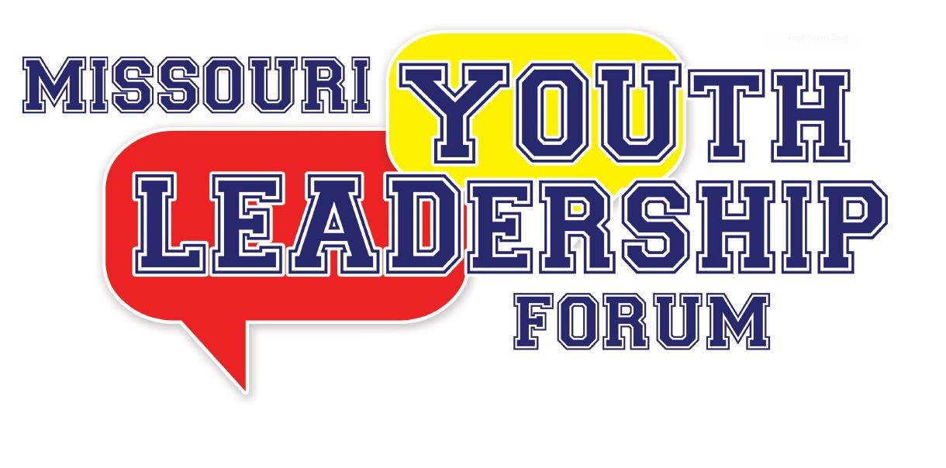

Volunteer Application
(Only coming for one activity or not all week-long positions)

Please read all instructions. Please fill out the entire application marking sections that do not apply appropriately with N/A. The application deadline is April 15, 2024. There are a fixed number of volunteer staff positions.

Options for submitting your completed application:

Upload to:
https://tinyurl.com/2024MOYLF

Fax to:
573-526-4109

Mail to:
Governor’s Council on Disability
Missouri Youth Leadership Forum
PO Box 1668
Jefferson City, MO 65102

Have questions or need assistance submitting your application?
Call: 800-877-8249 or 573-751-2600
OR
Email: gcd@oa.mo.gov

2024 MISSOURI YOUTH LEADERSHIP FORM
VOLUNTEER APPLICATION

** If you are selected as a volunteer, you will receive additional forms to complete after the application deadline. These forms will be sent to the email you list below and must be completed to serve as a volunteer**

Name (First) ___________________________ (M.I.) _____ (Last) ___________________________

Nickname/Preferred Name: ______________________________

Gender:_____________________ Pronouns:__________________

Mailing Address: ________________________________________________

City: ________________________ State: ____________ Zip Code: _____________

Telephone: _____________________________ E-mail: ___________________________

T-Shirt Size: _________________________

Applicant Status: Check ALL that apply:

____ New Volunteer Applicant (please complete the References and Experience section below)

____ YLF Alumni, if checked, the year you attended YLF _________

____ Former YLF volunteer or staff member, year(s) on staff __________, _________, _________

** FOR NEW VOLUNTEER APPLICANTS ONLY**

REFERENCES (please list two, include telephone number)

- _________________________________ Telephone: _______________________________

- ________________________________ Telephone: ______________________________

EXPERIENCE

What prior experience do you have that would be beneficial to you being a staff volunteer at MO-YLF?
________________________________________________________________________________________________________________________________________________________________________________________________________________________________________________________________________________________________________________

AVAILABILITY: Please check all dates/times that you are available to volunteer during the week of MO-YLF:

Tuesday, July 16th
Morning Afternoon Evening
Wednesday, July 17th
Morning Afternoon Evening
Thursday, July 18th
Morning Afternoon Evening
Friday, July 19th
Morning Afternoon Evening
Saturday, July 20th
Morning Afternoon Evening

Please check any accommodations that you will need while serving as a volunteer at MO-YLF:
Sign Language Interpreter
Assistive Listening Devices
Real-Time Captioning Braille Materials
Large Print Materials – Font Size: ________ Flash drive w/ electronic materials
Other – Please Specify: _________________________________________________________

**Since most equipment will be rented for the week or contracted out, failure to state the equipment or accommodations required may lead to those accommodations not being available during YLF.
[If needed, include an extra page with your application to provide any additional information]

If you are selected for a volunteer position, we expect you to be present and committed to fulfilling your responsibilities at the 2024 MO-YLF. As a volunteer, your dedication and active participation are crucial in ensuring the smooth operation of the event and making a meaningful impact on the lives of the participants. By accepting a volunteer role, you are committing to be present and fully engaged during the designated days and times assigned to you. However, we understand that unforeseen circumstances may arise. In such cases, we kindly request that you promptly inform the Governor’s Council on Disability office, so that appropriate arrangements can be made to find a replacement. Should you have any questions or need clarification, please contact the Governor’s Council on Disability office at (573) 751-2600 or gcd@oa.mo.gov.
Signature: ___________________________________

