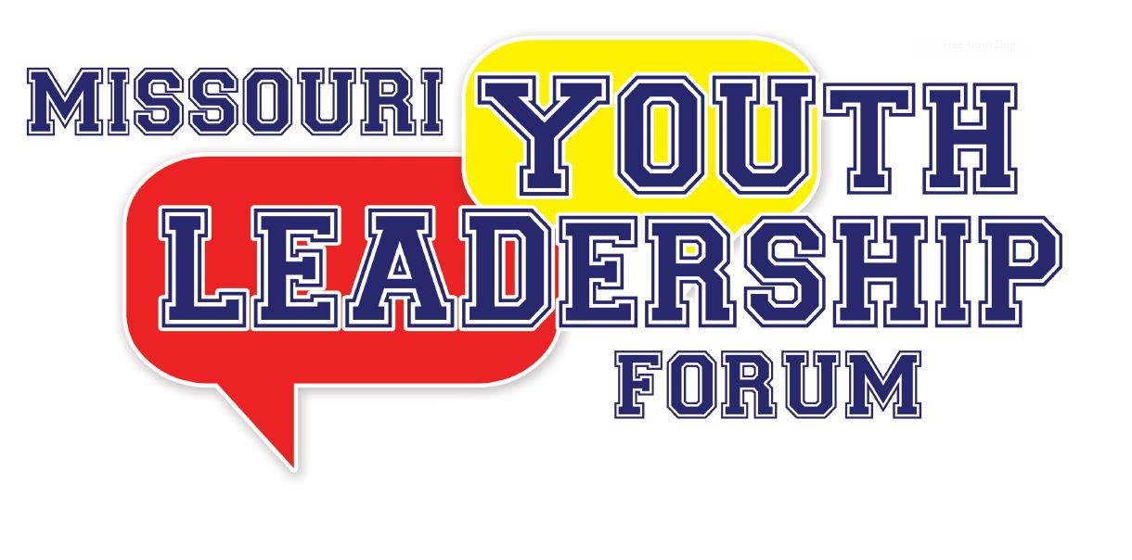

Volunteer Staff Application

Please read all instructions. Please fill out the entire application marking sections that do not apply appropriately with N/A. The application deadline is April 15, 2024. There are a fixed number of volunteer staff positions.

Options for submitting your completed application:

Upload to:
https://tinyurl.com/2024MOYLF

Fax to:
573-526-4109

Mail to:
Governor’s Council on Disability
Missouri Youth Leadership Forum
PO Box 1668
Jefferson City, MO 65102

Have questions or need assistance submitting your application?
Call: 800-877-8249 or 573-751-2600
OR
Email: gcd@oa.mo.gov

2024 MISSOURI YOUTH LEADERSHIP FORM
VOLUNTEER STAFF APPLICATION

** If you are selected to be a staff member, you will receive additional forms to complete after the application deadline. These forms will be sent to the email you list below and must be completed to serve as a staff member**

Staff Dates: Monday, July 15, 2024, through Saturday, July 20, 2024
The application deadline is April 15, 2024

Name (First) ___________________________ (M.I.) _____ (Last) ___________________________

Nickname/Preferred Name: ______________________________

Gender: _____________________ Pronouns: __________________

Mailing Address: ________________________________________________

City: ________________________ State: ____________ Zip Code: _____________

Telephone: _____________________________ E-mail: ___________________________

T-Shirt Size: _________________________ Position Interested In: _________________________

============================================================================================

Applicant Status: Check ALL that apply:

____ New Staff Applicant (please complete the References and Experience section below)

____ YLF Alumni, if checked, the year you attended YLF _________

____ Former YLF staff member, year(s) on staff __________, _________, _________, _________.

** FOR NEW STAFF APPLICANTS ONLY**

REFERENCES (please list two, include telephone number)

- _________________________________ Telephone: _______________________________

- ________________________________ Telephone: ______________________________

EXPERIENCE

What prior experience do you have that would be beneficial to you being a staff volunteer at MO-YLF?
________________________________________________________________________________________________________________________________________________________________________________________________________________________________________________________________________________________________________________
=========================================================================
Please check any accommodations that you will need while serving as a volunteer at MO-YLF:
Sign Language Interpreter Real-Time Captioning
Assistive Listening Devices Wheelchair Accessible Room
Shower Chair / Bench Roll-In Shower Braille Materials
Large Print Materials – Font Size: ________ Flash drive w/ electronic materials
Other – Please Specify: _________________________________________________________

**Since most equipment will be rented for the week, failure to state equipment required for accommodations (ie wheelchair, shower chair, etc) may lead to those accommodations not being available during YLF.
[If necessary, use the back of this page to list any additional details.]

=============================================================================
Background Check Information

Full Legal Name: __________________________________

Please list any other names you have used (Examples: Maiden, Previous Marriage, Legal Name Change):
______________________________________________________________________

Social Security Number: _____________________________

Date of Birth: _________________________

To participate in the 2024 YLF, volunteers who work with minors are required to undergo a criminal background check through the Family Care Registry. Your information will only be used for this purpose. By signing below, you give permission to the YLF Planning Committee to conduct the necessary background checks. Should you have any questions about this process, please contact the Governor’s Council on Disability office at gcd@oa.mo.gov or by calling 573-751-2600.

Signature: ___________________________________

============================================================================================

If chosen as a Facilitator or Team Member, I will be present for the Youth Leadership Forum from 1:00 p.m., Monday, July 15, 2024, until 3:00 p.m., Saturday, July 20, 2024. Starting from July 16, 2024, when the delegates arrive, I will always remain with them, not being able to leave the dorm at night or the campus during the day, until the checkout on July 20, 2024. I will also adhere to all the rules and regulations of the University of Missouri Columbia resident hall regarding my involvement in YLF. If I am unable to fulfill this role, I will promptly inform the Governor’s Council on Disability office to find a replacement. Should there are any questions or need for clarification, I will contact Governor’s Council on Disability office at (573) 751-2600 or gcd@oa.mo.gov.

Signature: ___________________________________

