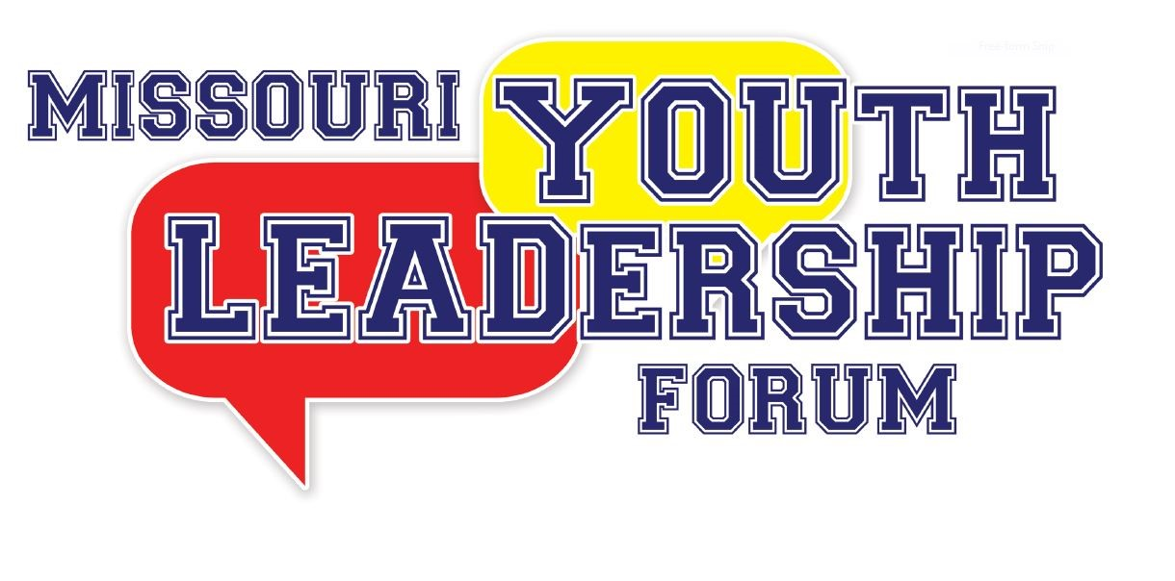

Staff and Volunteer Application

Please read all instructions. Please fill out the entire application marking sections that do not apply appropriately with N/A. The application deadline is April 1, 2026. There are a fixed number of staff and volunteer staff positions.

Options for submitting your completed application:

Upload to:
https://tinyurl.com/GCD-MOYLF

Fax to:
573-526-4109

Mail to:
Governor’s Council on Disability
Missouri Youth Leadership Forum
PO Box 1668
Jefferson City, MO 65102

Have questions or need assistance submitting your application?
Call: 800-877-8249 or 573-751-2600
OR
Email: gcd@oa.mo.gov

2026 MISSOURI YOUTH LEADERSHIP FORM
STAFF AND VOLUNTEER APPLICATION

** If you are selected as a staff or volunteer, you will receive additional forms to complete after the application deadline. These forms will be sent to the email you list below and must be completed to serve as a staff or volunteer**

Name (First) ___________________________ (M.I.) _____ (Last) ___________________________

Nickname/Preferred Name: ______________________________

Gender: _____________________ Pronouns: __________________

Mailing Address: ________________________________________________

City: ________________________ State: ____________ Zip Code: _____________

Telephone: _____________________________

E-mail: __________________________________________________________________________

T-Shirt Size: _______________ Position Interested In: ___________________________________

Applicant Status: Please select one:

____ New Staff Applicant (please complete the References and Experience section below)

____ New Volunteer Applicant (please complete the References and Experience section below)

____ Returning Staff/Volunteer Applicant

** FOR NEW VOLUNTEER APPLICANTS ONLY**

REFERENCES (please list two, include telephone number)

- _________________________________ Telephone: _______________________________

- _________________________________ Telephone: _______________________________

EXPERIENCE

What prior experience do you have that would be beneficial to you being a staff/volunteer at MO-YLF?
________________________________________________________________________________________________________________________________________________________________________________________________________________________________________________________________________________________________________________

AVAILABILITY: Please check all dates/times that you are available to attend or volunteer during the week of MO-YLF:

Available all week:

Monday, July 13th
Morning Afternoon Evening
Tuesday, July 14th
Morning Afternoon Evening
Wednesday, July 15th
Morning Afternoon Evening
Thursday, July 16th
Morning Afternoon Evening
Friday, July 17th
Morning Afternoon Evening
Saturday, July 18th
Morning Afternoon Evening

Please check any accommodations that you will need while serving as a staff or volunteer at MO-YLF:
Sign Language Interpreter
Assistive Listening Devices
Real-Time Captioning
Braille Materials
Large Print Materials – Font Size: ________
Flash drive w/ electronic materials.
Other – Please Specify: _________________________________________________________

**Since most equipment will be rented for the week or contracted out, failure to state the equipment or accommodations required may lead to those accommodations not being available during YLF.

[If needed, include an extra page with your application to provide any additional information]

Background Check Information

Full Legal Name: _____________________________________________________

Please list any other names you have used (Examples: Maiden, Previous Marriage, Legal Name Change): ____________________________________________________________

Social Security Number: _______________________________________________

Date of Birth: _________________________________________________________

To participate in the 2026 YLF, staff and volunteers who work with minors are required to undergo a criminal background check through the Family Care Registry. Your information will only be used for this purpose. By signing below, you give permission to the YLF Planning Committee to conduct the necessary background checks. Should you have any questions, about this process, please contact the Governor’s Council on Disability office at gcd@oa.mo.gov or by calling 573-751-2600.

Signature: ________________________________________

===============================================================================

If you are selected for a staff/volunteer position, we expect you to be present and committed to fulfilling your responsibilities at the 2026 MO-YLF. As a staff member/volunteer your dedication and active participation are crucial in ensuring the smooth operation of the event and making a meaningful impact on the lives of the participants.
If chosen for a volunteer role, I am committing to being present and fully engaged during the designated days and times assigned to me.
If chosen as a Facilitator or Team Member, I will be present for the Missouri Youth Leadership Forum for the entire event from July 13 – 18, 2026.

Signature: ___________________________________

We understand that unforeseen circumstances may arise. If you cannot participate in your designated role, we kindly request that you promptly inform the Governor’s Council on Disability office, so that appropriate arrangements can be made to find a replacement. Should you have any questions or need clarification, please contact the Governor’s Council on Disability office at (573) 751-2600 or gcd@oa.mo.gov.

